**Writing a C# API for the USIBO24 Elexol**

<https://www.elexol.com/IO_Modules/documents/USBIO24DIPRDS1.pdf>

Following this document, I create a c# class to handle the Elexol USBIO24

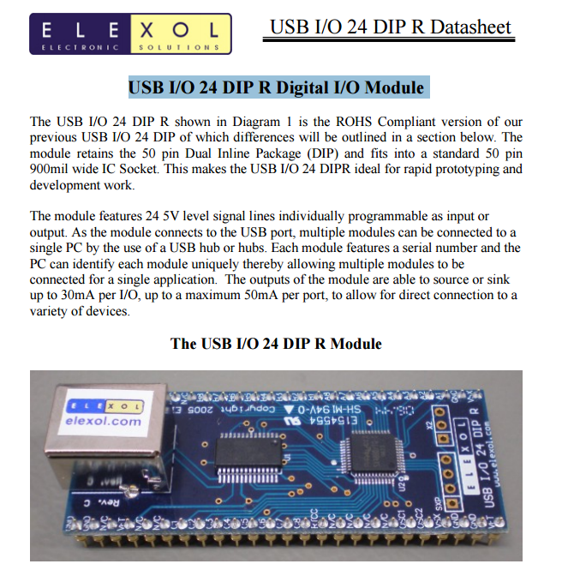

The above link for the document explain how to read and write from the Elexol io

There are two options

1. Use serial COM port read and write
2. Use the FTDI driver wrapper in c#

The easy way is to use the Serial Com port read and write as described in the document

|  |
| --- |
| using EleXolIO24RApi;  using System;  using System.Collections.Generic;  using System.IO.Ports;  using System.Linq;  using System.Text;  using System.Threading;  using System.Threading.Tasks;  namespace EleXolIO24RApi  {  public class elexol_asuart  {  SerialPort _serialPort = new SerialPort();  byte[] buf = new byte[250];  byte[] m_direction = new byte[1];  public elexol_asuart(string COMPORT)  {  _serialPort.PortName = COMPORT;  _serialPort.BaudRate = 115200;  _serialPort.Parity = Parity.None;  _serialPort.DataBits = 8;  _serialPort.StopBits = StopBits.One;  //_serialPort.Handshake = Handshake.XOnXOff;  }  public elexol_asuart GetBase()  {  return this;  }  public virtual bool Open()  {  _serialPort.Open();  return _serialPort.IsOpen;  }  public virtual void Close()  {  if (_serialPort != null && _serialPort.IsOpen)  _serialPort.Close();    }  public virtual void setAllDirection(DIRECTION_ALL direction)  {  lock (this)  {  string[] strPorts = { "!A", "!B", "!C" };  foreach (string s in strPorts)  {  _serialPort.Write(s);  if (direction == DIRECTION_ALL.OUTPUT)  m_direction[0] = 0x0;  else  m_direction[0] = 0xFF;  _serialPort.Write(m_direction, 0, 1);  }  }  }  public virtual void setDirection(PORT_NUMBER port, DIRECTION_ALL direction)  {  lock (this)  {  string portStr = string.Empty;  switch (port)  {  case PORT_NUMBER.PORTA:  portStr = "!A";  break;  case PORT_NUMBER.PORTB:  portStr = "!B";  break;  case PORT_NUMBER.PORTC:  portStr = "!C";  break;  }    if (direction == DIRECTION_ALL.OUTPUT)  m_direction[0] = 0x0;  else  m_direction[0] = 0xFF;  _serialPort.Write(portStr);  _serialPort.Write(m_direction, 0, 1);  }  }  public virtual void setDirection(PORT_NUMBER port, DIRECTION direction, byte inputPins)  {  lock (this)  {  string portStr = string.Empty;  switch (port)  {  case PORT_NUMBER.PORTA:  portStr = "!A";  break;  case PORT_NUMBER.PORTB:  portStr = "!B";  break;  case PORT_NUMBER.PORTC:  portStr = "!C";  break;  }  if (direction == DIRECTION.OUTPUT)  m_direction[0] &= inputPins;  else  m_direction[0] |= inputPins;  _serialPort.Write(portStr);  _serialPort.Write(m_direction, 0, 1);  }  }  public virtual void Write(PORT_NUMBER port, byte value)  {  string portStr = string.Empty;  switch (port)  {  case PORT_NUMBER.PORTA:  portStr = "A";  break;  case PORT_NUMBER.PORTB:  portStr = "B";  break;  case PORT_NUMBER.PORTC:  portStr = "C";  break;  }  _serialPort.Write(portStr);  _serialPort.Write(buf, 0 , 1);  }  public virtual void Write(char port, byte value)  {  _serialPort.Write(port.ToString());  _serialPort.Write(buf, 0, 1);  }  public virtual void Write(PORT_NUMBER port, byte writePins, byte value)  {  setDirection(port, DIRECTION.OUTPUT, writePins);  string portStr = string.Empty;  switch (port)  {  case PORT_NUMBER.PORTA:  portStr = "A";  break;  case PORT_NUMBER.PORTB:  portStr = "B";  break;  case PORT_NUMBER.PORTC:  portStr = "C";  break;  }  _serialPort.Write(portStr);  _serialPort.Write(buf, 0, 1);  }  public virtual bool ReadPort(PORT_NUMBER port, out byte valueRead)  {  valueRead = 0;  string portStr = string.Empty;  switch (port)  {  case PORT_NUMBER.PORTA:  portStr = "a";  break;  case PORT_NUMBER.PORTB:  portStr = "a";  break;  case PORT_NUMBER.PORTC:  portStr = "a";  break;  }  _serialPort.Write(portStr);  setDirection(port, DIRECTION_ALL.INPUT);  int timeout = 0;  while (_serialPort.BytesToRead == 0)  {  Thread.Sleep(10);  if (timeout == 100)  return false;  timeout++;  }  if (_serialPort.BytesToRead == 1)  {  _serialPort.Read(buf, 0, 1);  valueRead = buf[0];  Console.WriteLine(buf[0].ToString());  return true;  }  else  {  return false;  }  }  public virtual bool Read(PORT_NUMBER port, byte InputPins, out byte valueRead)  {  valueRead = 0;  string portStr = string.Empty;  switch (port)  {  case PORT_NUMBER.PORTA:  portStr = "a";  break;  case PORT_NUMBER.PORTB:  portStr = "a";  break;  case PORT_NUMBER.PORTC:  portStr = "a";  break;  }  _serialPort.Write(portStr);  setDirection(port, DIRECTION.INPUT, InputPins);  int timeout = 0;  while (_serialPort.BytesToRead == 0)  {  Thread.Sleep(10);  if (timeout == 100)  return false;  timeout++;  }  if (_serialPort.BytesToRead == 1)  {  _serialPort.Read(buf, 0, 1);  valueRead = buf[0];  Console.WriteLine(buf[0].ToString());  return true;  }  else  {  return false;  }  }  }  } |

Some notes:

1. The API provides set of overloaded function to read a complete port ( 8 bits)

Or write and read to specific pin

1. Pay attention on the timeout , the read does not work immediately



